**MONGODB ASSIGNMENT 3**

1. **Total sales per product.**

db.sales.aggregate([{$project: {

product: 1,

total_sales: { $multiply: ["$price", "$quantity"]}}},

{$group: {_id: "$product",

total_sales: { $sum: "$total_sales" }}}])

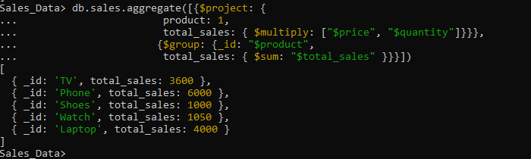

1. **Total revenue per product.**

db.sales.aggregate([{$group:{_id:"$product",

total_revenue:{$sum:{

$multiply:["$price","$quantity"]}}}}])

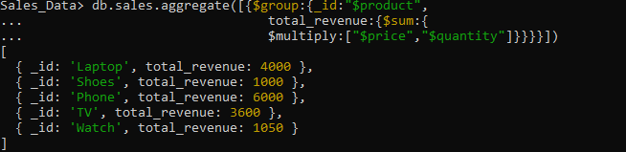

1. **Total revenue per category.**

db.sales.aggregate([{$group:{_id:"$category",

total_revenue:{$sum:{

$multiply:["$price","$quantity"]}}}}])

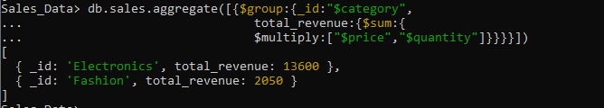

1. **Count of products per category**.

db.sales.aggregate([{$group:{_id:"$category",

prod_category:{$sum:"$quantity"}}}])

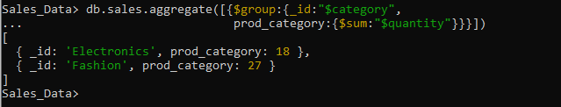

1. **Store-wise total sales.**

db.sales.aggregate([{$group:{_id:"$store",

total_revenue:{$sum:{

$multiply:["$price","$quantity"]}}}}])

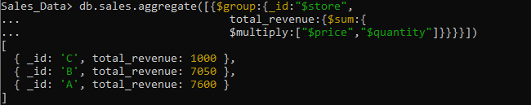

1. **Average price of products per category.**

**db.sales.aggregate([{$group:{_id:"$category",**

**avg_price:{$avg:"$price"}}}])**

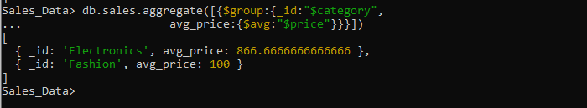

1. **Top-selling product.**

**db.sales.aggregate([{$group:{_id:"$product",**

**top_product:{$sum:"$quantity"}}},**

**{$sort:{top_product:-1}},{$limit:1}])**

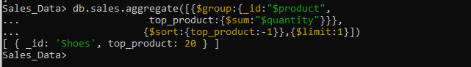

1. **Total sales for Electronics category.**

**db.sales.aggregate([{$match:{category:"Electronics"}},**

**{$group:{_id:null,revenue:{$sum:{$multiply:["$price","$quantity"]}}, sales:{$sum:"$quantity"}}}])**

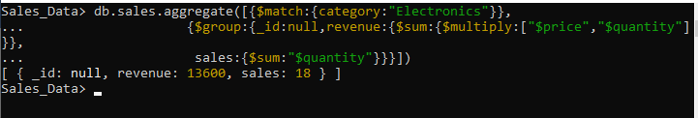

1. **Sales trend over time (day-wise total sales).**

db.sales.aggregate([{$group:{_id:{$dateToString:{format:"%Y-%m-%d",date:"$date"}},

sales:{$sum:{$multiply:["$price","$quantity"]}}}},

{$sort:{_id:1}}])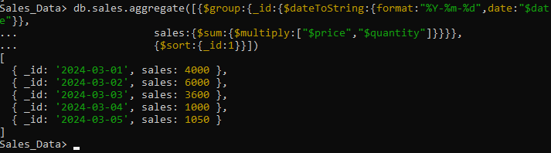

1. **Highest revenue-generating product.**

**db.sales.aggregate([{$group:{_id:"$product",**

**sales:{$sum:{$multiply:["$price","$quantity"]}}}},**

**{$sort:{sales:-1}},{$limit:1}])**

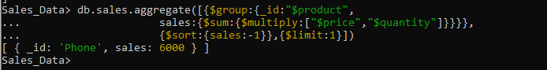

1. **Average revenue per sale.**

**db.sales.aggregate([{$group:{_id:null,**

**avgrevenue:{$avg:{$multiply:["$price","$quantity"]}}}}])**



1. **Sales performance per store.**

**db.sales.aggregate([{$group:{_id:"$store",**

**revenue:{$sum:{$multiply:["$price","$quantity"]}},**

**sales:{$sum:"$quantity"}}}])**

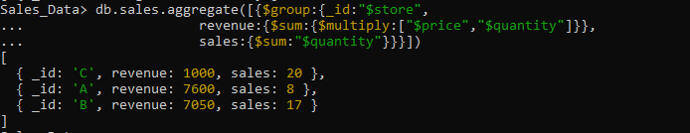

1. **Products sold more than 5 times.**

**db.sales.aggregate([{$group:{_id:"$product",qty_sold:{$sum:"$quantity"}}},**

**{$match:{qty_sold:{$gt:5}}}])**

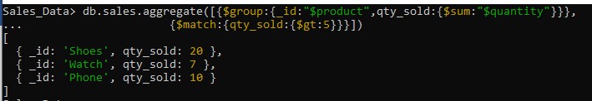

1. **Least sold product.**

**db.sales.aggregate([{$group:{_id:"$product",qty_sold:{$sum:"$quantity"}}},**

**{$sort:{qty_sold:1}},{$limit:1}])**

1. **Monthly sales summary.**

**db.sales.aggregate([{$group:{_id:{$dateToString:{format:"%Y-%m",date:"$date"}},**

**revenue:{$sum:{$multiply:["$price","$quantity"]}},**

**sales:{$sum:"$quantity"}}}])**

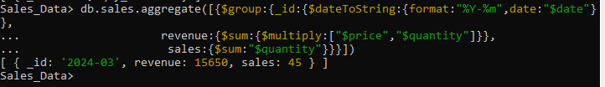

1. **Number of unique products sold.**

**db.sales.distinct("product").length**



1. **Maximum and minimum priced product.**

**db.sales.aggregate([{$sort:{"price":-1}},**

**{$group:{_id:null,**

**max_price_prod:{$first:"$product"},max_price:{$first:"$price"},**

**min_price_prod:{$last:"$product"},min_price:{$last:"$price"}}}])**

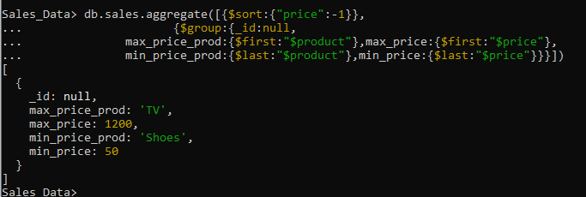

1. **Total revenue per product in descending order.**

**db.sales.aggregate([{$group:{_id:"$product",**

**total_revenue:{$sum:{$multiply:["$price","$quantity"]}}}},**

**{$sort:{total_revenue:-1}}])**

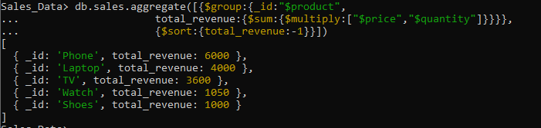

1. **Revenue generated per store per category.**

**db.sales.aggregate([{$group:{_id:{store:"$store",category:"$category"},**

**total_revenue:{$sum:{$multiply:["$price","$quantity"]}}}}])**

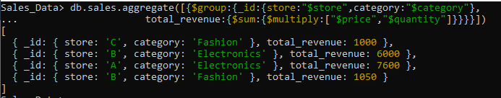

**20. Products contributing more than 50% revenue.**

db.sales.aggregate([{$group:{_id:null,

total_revenue:{$sum:{$multiply:["$price","$quantity"]}}}},

{$group:{_id:"$product",

prod_revenue:{$sum:{$multiply:["$price","$quantity"]}}}},

{$match:{$expr:{$gt:["$prod_revenue",{$multiply:["$total_revenue",0.5]}]}}}]) 